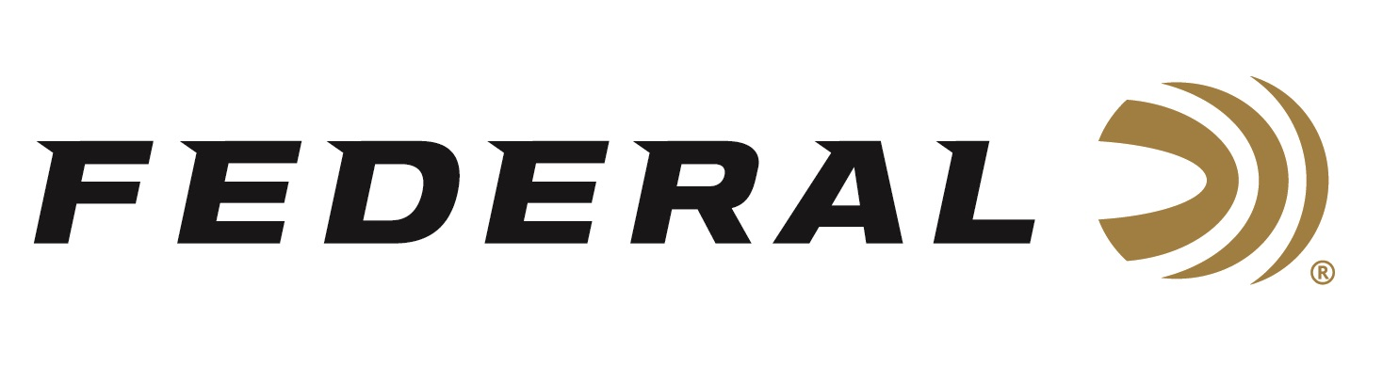

FOR IMMEDIATE RELEASE

TV’s Power Couple Crushing It on “It’s Federal Season” Podcast

ANOKA, Minnesota – April 15, 2021 – On this episode of the “It’s Federal Season” podcast, outdoor television’s power couple Lee and Tiffany Lakosky join Federal Ammunition’s Vice President of Marketing Jason Nash and Director of Media Brian Kelvington for a comprehensive discussion on the rise and success of their outdoor television careers. From the time they met, to getting their feet wet in outdoors television production, to their deer management practices, this conversation is packed from start to finish.

Episode No. 20 - Crushed It
https://www.federalpremium.com/this-is-federal/podcast/

“The Lakosky’s are very enthusiastic, and this is a fun and fast paced discussion,” said Jason Nash, Vice President of Marketing. “Besides the commitment to producing great entertainment for viewers of Outdoor Channel, the Lakosky’s are conservationists and share their system and philosophy in growing and harvesting big bucks,” said Nash.

In the Tech Talk segment, shotshell product line Dan Compton will get turkey hunters ready for the spring season and has a comprehensive review on Federal’s line up of ammunition to take a big tom. Before leaving, listen for the latest on available promotions from Federal during the News and Notes segment.

For this episode, besides listening on your favorite podcast platform, you can also subscribe to Federal Ammunition’s YouTube channel and tune in for the discussion: https://youtu.be/Ak0O_d4gZpg.

Federal Ammunition can be found at dealers nationwide or purchased online direct from Federal. For more information on all products from Federal or to shop online, visit www.federalpremium.com.

Press Release Contact: JJ Reich
Senior Manager – Press Relations
E-mail: VistaPressroom@VistaOutdoor.com

About Federal Ammunition
Federal, headquartered in Anoka, MN, is a brand of Vista Outdoor Inc., an outdoor sports and recreation company. From humble beginnings nestled among the lakes and woods of Minnesota, Federal Ammunition has evolved into one of the world's largest producers of sporting ammunition. Beginning in 1922, founding president, Charles L. Horn, paved the way for our success. Today, Federal carries on Horn's vision for quality products and service with the next generation of outdoorsmen and women. We maintain our position as experts in the science of ammunition production. Every day we manufacture products to enhance our customers' shooting experience while partnering with the conservation organizations that protect and support our outdoor heritage. We offer thousands of options in our Federal Premium and Federal® lines-it's what makes us the most complete ammunition company in the business and provides our customers with a choice no matter their pursuit.

